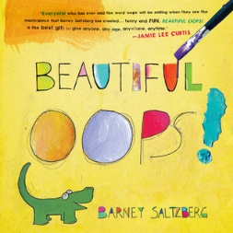 | Beautiful Oops Barney Saltzberg  A life lesson that all parents want their children to learn: It’s OK to make a mistake. In fact, hooray for mistakes! A mistake is an adventure in creativity, a portal of discovery. A spill doesn’t ruin a drawing—not when it becomes the shape of a goofy animal. And an accidental tear in your paper? Don’t be upset about it when you can turn it into the roaring mouth of an alligator.
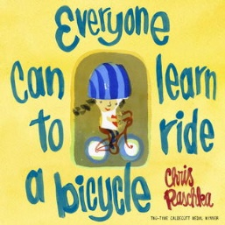 | Everyone can Learn to Ride a Bicycle Chris Raschka  A bright, science-minded boy goes to the beach equipped to collect and examine flotsam--anything floating that has been washed ashore. Bottles, lost toys, small objects of every description are among his usual finds. But there's no way he could have prepared for one particular discovery: a barnacle-encrusted underwater camera, with its own secrets to share and to keep.
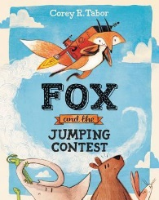 | Fox and the Jumping Contest Corey R Tabor  Fox and the Jumping Contest is a funny, surprising picture book starring Fox—a lovable modern-day trickster character—and his animal friends, from debut author-illustrator Corey R. Tabor.  Fox really, really wants to win the jumping contest. He knows just where he’ll put that first-place trophy. The only problem? Fox is not a very good jumper. But he is a very good schemer. ....
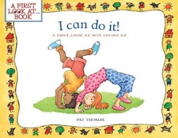 | I can do it Pat Thomas  This thought-provoking book opens with a question to its young readers: "Have you ever tried to do something that was really hard?" Kids discover that learning to do new things--even when they are difficult--makes life more interesting. Whether learning a new sport, learning to play a musical instrument, or learning any new skill, kids shouldn't be afraid to make mistakes. The most important thing is for them to try their best.
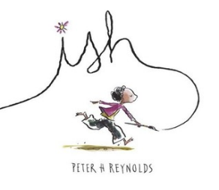 | Ish Peter H Reynolds  Ramon loved to draw. Anytime. Anything. Anywhere.  Drawing is what Ramon does. It¹s what makes him happy. But in one split second, all that changes. A single reckless remark by Ramon's older brother, Leon, turns Ramon's carefree sketches into joyless struggles. Luckily for Ramon, though, his little sister, Marisol, sees the world differently. She opens his eyes to something a lot more valuable than getting things just "right." Combining the spareness of fable with the potency of parable, Peter Reynolds shines a bright beam of light on the need to kindle and tend our creative flames with care
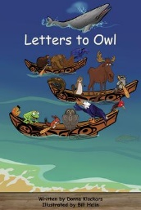 | Letters to Owl  All the animals are getting ready for a Summer Feast. Some of the animals are having a hard time getting all the work completed.  Owl is famous for helping his friends solve problems. The animals write Owl letters asking for help.  Can you predict some of the problems that Owl helps solve? How do you solve problems?
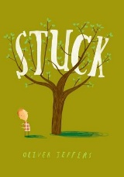 | Stuck Oliver Jeffers  When Floyd's kite gets stuck in a tree, he's determined to get it out. But how? Well, by knocking it down with his shoe, of course. But strangely enough, it too gets stuck. And the only logical course of action . . . is to throw his other shoe. Only now it's stuck! Surely there must be something he can use to get his kite unstuck. An orangutan? A boat? His front door? Yes, yes, and yes. And that's only the beginning.
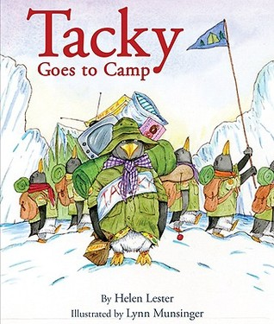 | Tacky Goes to Camp  Tacky and his fellow penguins are off to summer camp in Nice Icy Land to enjoy themselves while Rock Hopping, Line Dancing, and playing Capture the Ice Cube. One night, they gather around the campfire to sing, eat s’mores, and tell scary stories. But after going to bed, something straight out of one of their scary stories pays the sleeping penguins a visit. Goodly, Lovely, Angel, Neatly, and Perfect think they should high-tail it out of there, but it is Tacky—with some unexpected heroics—who saves the day.
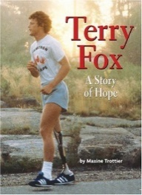 | Terry Fox – A Story of Hope Maxine Trootier  Terry Fox liked to finish what he started. He always wanted to do his best. So at the age of 18, when his right leg was amputated, he worked hard to recover. He had a dream – to run across Canada to raise money for cancer research.
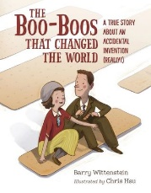 | The Boo-Boos that Changed the World: A True Story about an Accidental Invention Barry Wittenstein  Earle's wife was kind of klutzy and often cuts and burns herself around the house. Ouch! Earl figures out a way to make easy to use bandages for Josephine. Early just wants to help his wife. He doesn’t mean to invent something important.
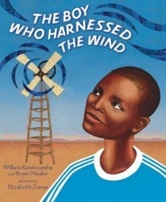 | The Boy Who Harnessed the Wind William Kamkwamba & Bryan Mealer  When fourteen-year-old William Kamkwamba's Malawi village was hit by a drought, everyone's crops began to fail. Without enough money for food, let alone school, William spent his days in the library . . . and figured out how to bring electricity to his village. Persevering against the odds, William built a functioning windmill out of junkyard scraps, and thus became the local hero who harnessed the wind.
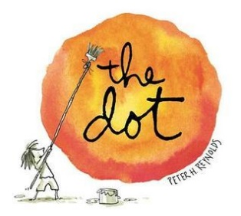 | The Dot Peter H Reynolds  Her teacher smiled. "Just make a mark and see where it takes you."  Art class is over, but Vashti is sitting glued to her chair in front of a blank piece of paper. The words of her teacher are a gentle invitation to express herself. But Vashti can’t draw - she’s no artist. To prove her point, Vashti jabs at a blank sheet of paper to make an unremarkable and angry mark. "There!" she says.  That one little dot marks the beginning of Vashti’s journey of surprise and self-discovery. That special moment is the core of Peter H. Reynolds’s delicate fable about the creative spirit in all of us.
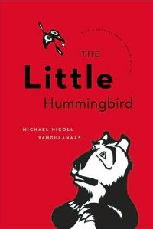 | The Little Hummingbird Michael Nicoll Yahgulanaas  This inspiring children's book-a revised edition of the awardwinning Flight of the Hummingbird-is based on a South American indigenous story about a courageous hummingbird who defies fear and expectations in her attempt to save the forest from fire. The illustrated story is supplemented by a natural and cultural history of hummingbirds, as well as an inspiring message from Nobel Peace Prize winner Wangari Maathai. The evocative artwork by internationally renowned Haida artist Michael Nicoll Yahgulanaas complements the optimistic tale that encourages everyone to take responsibility for their home and the planet.
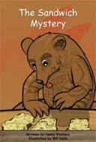 | The Sandwich Mystery Donna Klockars  Little Bear decides to visit Red Squirrel who lives in Pine Forest.  He prepares a tasty lunch for them but one of the sandwiches he made has disappeared. How do you think a sandwich could disappear?
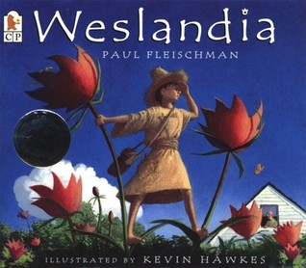 | Weslandia Paul Fleischman Becker  Enter the witty, intriguing world of Weslandia! Now that school is over, Wesley needs a summer project. He’s learned that each civilization needs a staple food crop, so he decides to sow a garden and start his own - civilization, that is. He turns over a plot of earth, and plants begin to grow. They soon tower above him and bear a curious-looking fruit. As Wesley experiments, he finds that the plant will provide food, clothing, shelter, and even recreation. It isn’t long before his neighbours and classmates develop more than an idle curiosity about Wesley - and exactly how he is spending his summer vacation.
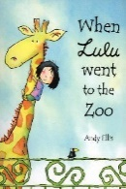 | When Lulu went to the Zoo. Andy Ellis  Lulu decides to release all the animals from their cages and takes them back to her house to live. However that turns out to be not quite such a good plan after all...
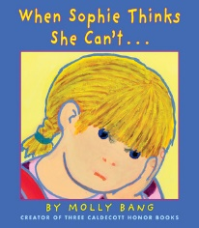 | When Sophie Thinks She Can't Molly Bang  How do you feel when you can't do a difficult task? Sophie learns a fun new way to solve problems, and you can too!
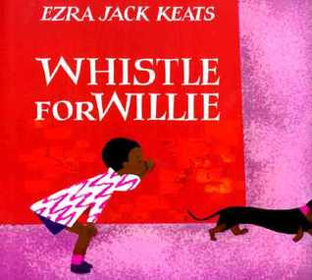 | Whistle for Willie  This is the simple story of Peter, who longs to whistle for his dog, Willie, and persists until he does. When Whistle for Willie was first published in 1964, The New York Times wrote, "Mr. Keats's illustrations boldly, colorfully capture the child, his city world, and the shimmering heat of a summer's day."

Updated February 2024

